1. **What is the difference between git clone and git pull:**

*Git clone* is the function that how people are using to get a local copy of an existing local repository to work on. It is usually only used once for a given repositor, unless people want to have multiple working copies of it around. (Or want to get a clean copy after messing up the local one.)

*Git pull* (Git fetch + Git merge) is how people update that local copy with new commits from the remote repository. If people are collaborating with others, it is a command that people will run frequently.

1. **Git add and Git reset**
2. *Git add：*

The command of git add mainly is used to upload the files that we need to the repository previously set up. When we use the command of git commit, one of functions of git is to upload the files according to the content of the repository,

* Git add <path> represents that adding to index only files created or modified and not those deleted. <path> could also be construed as a file format or directory format.
* Git add -u represents adding to index only files modified or deleted and not those created.
* Git add -A represents that including all the files modified or deleted, even those files which are under the status of untracted.
* Git add -I represents a function checking those files got detected or modified but have not yet been uploaded.

1. *Git reset:*

There are two main functions of git reset, which are retrieving files from the stage (Index) to the working directory temporarily and retrieving back to the previous version respectively.

There are three main realms about the git, they are working directory, stage index and history respectively as the following graph represents:

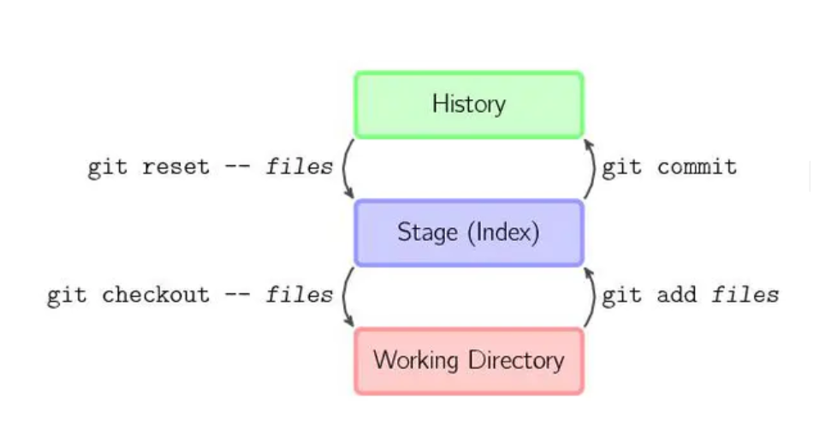

* Git reset –-hard xxx:

For this function, it will change all the history, stage, working directory sequentially, to be more specific, --hard Head~1 means retrieving the history back to the previous one but it does not only mean that altering the head pointer to the other versions, also means to reset the working directory and the stage.

* Git reset –soft xxx:

This command means to return back to the previous chapter but it will somehow retain the history of the stage and working directory.

**3.Status and log:**

*Git status*: The git status command displays the state of the working directory and the staging area. It lets people see which changes have been stages, which have not and which files are not being tracked by. Status output does not show any information regarding the committed project history unless use the command of git log.

*Git log:* The git log command displays committed snapshots. It lets people list the project history, filter it, and search for specific changes. While git status lets people inspect the working directory and the staging area, git log only operates the committed history.

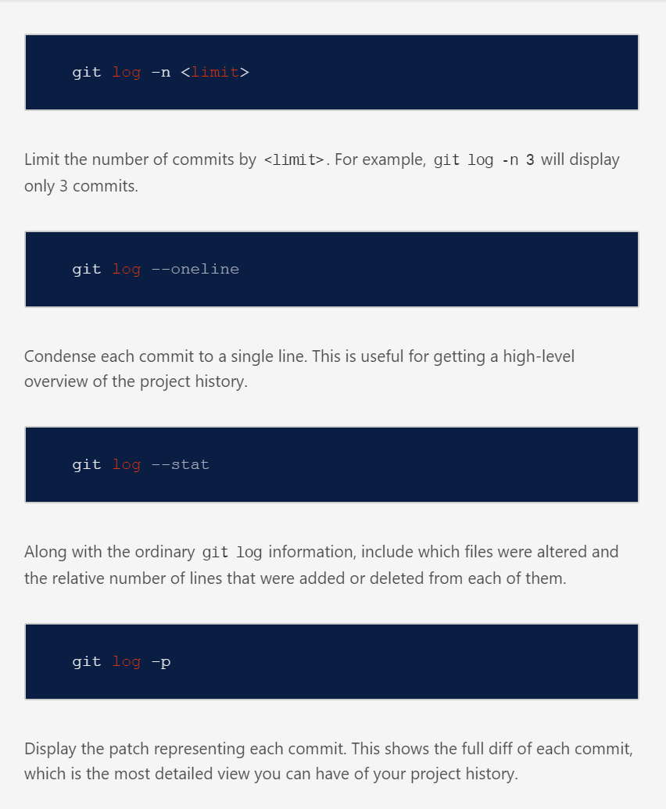

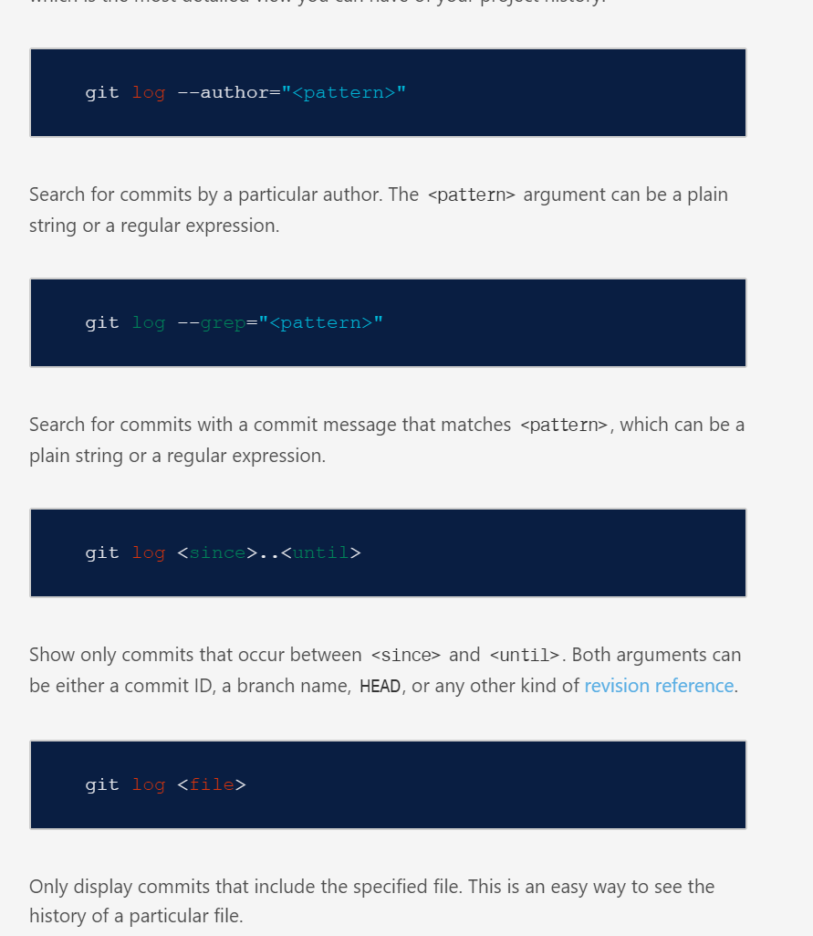

**4.Pull request**:

In the simplest form, pull requests are a mechanism for a developer to notify team members that they have completed a feature. Once their feature branch is ready, the developer files a pull request via their Bitbucket account. That lets everybody involved know that they need to review the code and merge it into the master branch.